(Sprint 4 Plan) Island Reservation

**Goal**: The goals of this sprint are to reach a minimum viable product, and focus on getting the reservation system working.

**Task listings:**

Note : User Stories carried over from Sprint 3 include Stories 1 and 2

**User Story 1: (Carried over from Sprint 3): As a person who wants to reserve an island, I want to be able to sort the list of available islands by different criteria (like price, land size, or rating) so I can easily find the island that is best for me. (13 story points)**

Task 1: Display the island information from the various endpoints on the website (3)

**User Story 2: (Carried over from Sprint 3): As a user of an island reservation service, I want a map of all of the islands so I can figure out which ones are closest to me. (13 story points)**

Task 1: Add a Google Maps map to the website. (4)

Task 2: Display and mark all island locations where the user can travel to. (2)

Task 3: Display the user’s location. (2)

Task 4: Write a get endpoint that takes in user coordinates and returns a sorted list of nearby islands (1)

Task 5: Use the endpoint to display a list of nearby islands sorted by ascending distance from the user. (3)

**User Story 3: As a user, I want to be able to book islands so I have a place to host my events or vacations. (13 story points)**

Task 1: Make reservations table (1)

Task 2: Create an endpoint to input reservations, checks if user has enough balance (subtract that balance), if the user has any existing reservations that conflict with the dates they chose, and also if there are any date conflicts for that island (5)

Task 3: Create a form to reserve islands (2)

Task 4: Connect the endpoint to the form to allow new reservations to be sent to the database. (1)

Task 5: Display the current user’s reservations on the user home page (3)

**User Story 4: As a user, I want a settings page so I can update my personal information. (6 story points)**

Task 1: Create a form that displays their old information and lets them input new information for name and password. (3)

Task 2: Create an endpoint that updates the user information accordingly. (2)

Task 3: Connect the endpoint to the form on the frontend. (0.5)

Task 4: Connect the settings page to the rest of the website. (0.5)

**User Story 5: As a user, I want to see a logo on the website I am using so that I know which website I am using and so that I feel as though it is a legitimate service. (5 story points)**

Task 1: Create a logo (one version for the Navbar, one version for the homepage) . (5)

Task 2: Display the logos on the homepage and the Navbar so that it will be shown on every page. (1)

**User Story 6: As a user, I want to be able to upload an island for others to reserve so that I can generate revenue and use site functionality. (13 story points)**

Task 1: Create an endpoint to add an island to the website (2)

Task 2: Create a form to add an island to the website (2)

Task 3: Connect the endpoint to the form (1)

Task 4: Connect the form to the rest of the website (0.5)

**User Story 7: As a user, I want to be able to read and leave reviews for islands I’ve reserved to know if an island is worth reserving. (10 story points)**

Task 1: Create reviews table (0.5)

Task 2: Create an endpoint to add reviews to the review table (2)

Task 3: Create review form to add a review to a specific island (2)

Task 4: Display the reviews for each island in the Detail page of that island (4)

Task 5: Allow the user to view all their previous reviews and delete them? (if we’re changing the user homepage area for the reviews to managing the reviews) (5)

**User Story 8: As a user, I want to be able to view the islands I’ve uploaded and edit their information (my own islands) for others to reserve. (9 story points)**

Task 1: Create a page which allows users to view all of their uploaded islands (5)

Task 2: Allow users to add additional islands (get to the add islands form) from this page (0.5)

Task 3: Allow users to reach a page which allows them to change and update the data fields for their previously uploaded islands (4)

**Team roles:**

Abdel Rahman Alnajjar : Frontend Developer

Suneet Bhandari : Frontend Developer

Minghui Wen : Frontend Developer

Maiah Pardo: Frontend Developer

Jonathan Ly : Backend Developer

Wilson Chen : Backend Developer

Jose Jimenez : Backend Developer

**Initial Task Assignment:**

Minghui Wen: User Story 1, task 1

Abdel Rahman Alnajjar: User Story 3, task 3

Wilson Chen: User Story 3, task 4

Suneet Bhandari: User Story 2, task 2

Jonathan Ly: User Story 3, task 2

Jose Jimenez: User Story 6, task 2

Maiah Pardo: User Story 4, task 3/ User Story 5: Task 1 and 2

**Burnup Chart:**

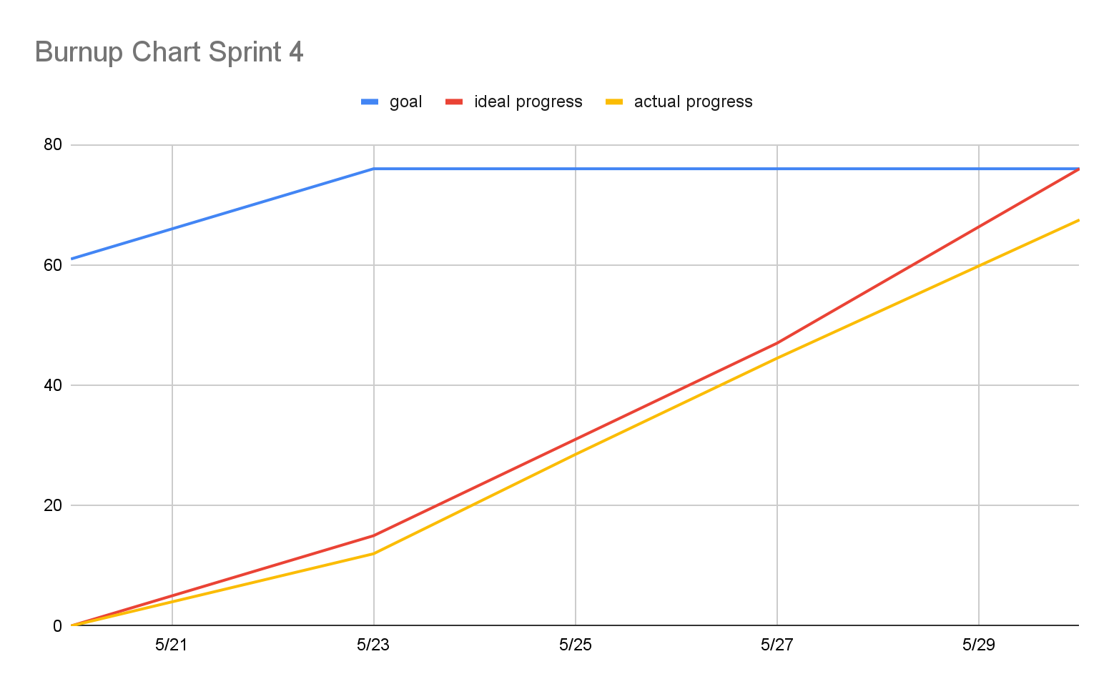

**Scrum Board:** <https://islandreservation.atlassian.net/jira/software/projects/IR/boards/1>

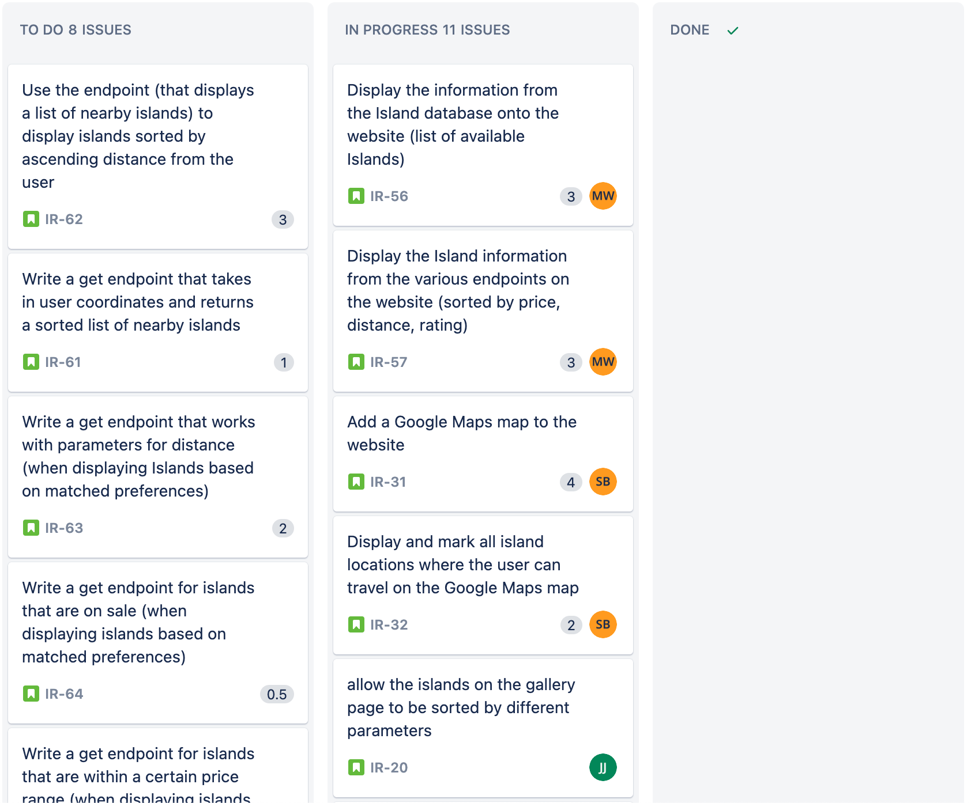

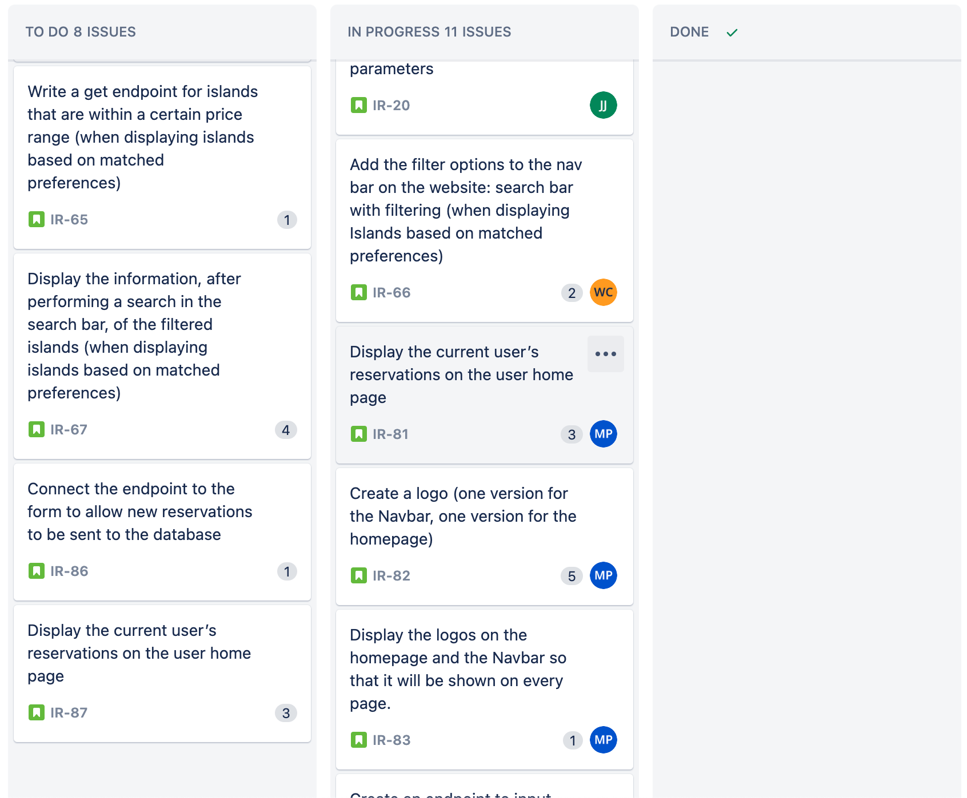

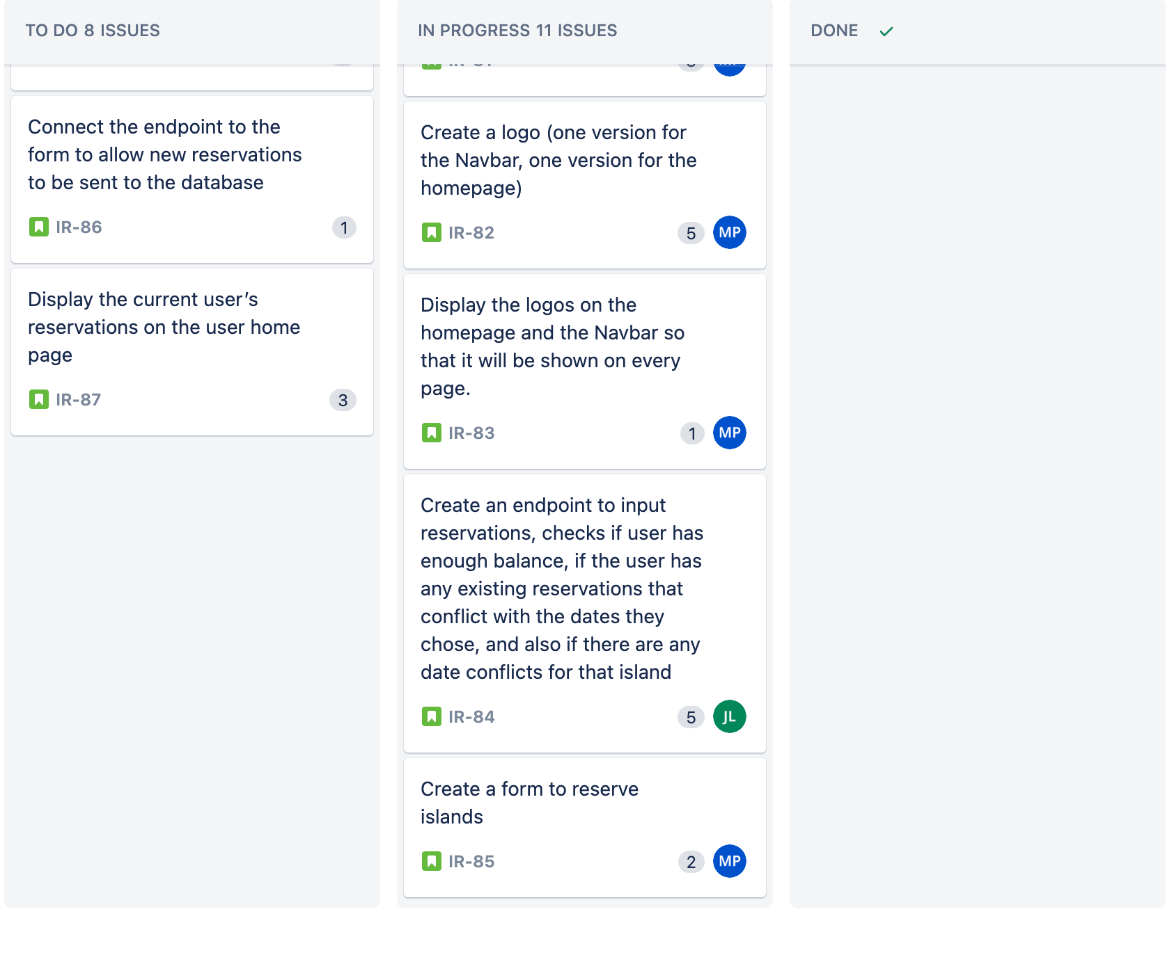

**Scrum Times:**

Mon/Wed/Fri : 9:05 - 9:30 am

TA meeting: Monday Trevor 1:30 - 2:45 pm